

**Discipline**

**Process Flow Chart**

**CS5201**

Stage-1

**Sheikh Muhammed Tadeeb (AU19B1014)**

* **Stakeholders:**

|  |  |  |
| --- | --- | --- |
| **Stakeholder Class** | **Rank** | **Rationale** |
| Cashier | 1 | They have most interaction with the system. |
| Business Customer | 6 | They have least direct interaction with the system. |
| Accountant | 2 | They read the reports. |
| Warehouse workers | 5 | They have least direct interaction with the system. |
| Seller | 4 | They may read the reports. |
| System maintenance person | 3 | They may have to fix things when system doesn’t work properly. |

* **Brainstorming:**

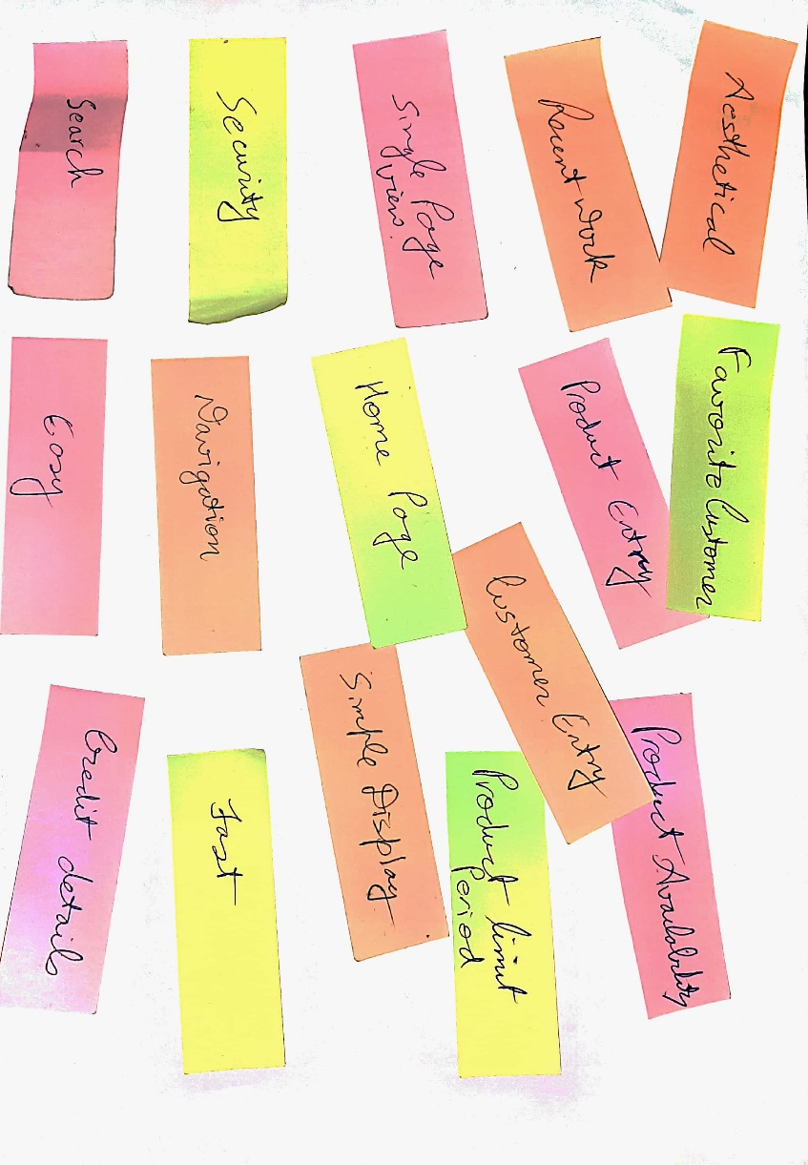

* **User needs and requirements:**

The following came out after taking user survey: -

|  |  |
| --- | --- |
| **Snos** | **Needs/Requirements** |
| 1. | The system must be easy to use. |
| 2. | The system must have all functionalities at one place. |
| 3. | The system must be able to print different details. |
| 4. | The system must be aesthetical. |
| 5. | The system must calculate credit on different customers. |
| 6. | The system must work fast. |
| 7. | The system must be secured. |
| 8. | The system must maintain a backup. |
| 9. | The system must a search feature. |
| 10. | The system must inform the goods which took 20 days & still aren’t sold. |
| 11. | The system shall have integrated bank api. |
| 12. | The system shall inform about the customers frequency. |
| 13. | The system shall give discount based on certain keywords. |
| 14. | The system must be cost-effective. |

* **Filtration:**

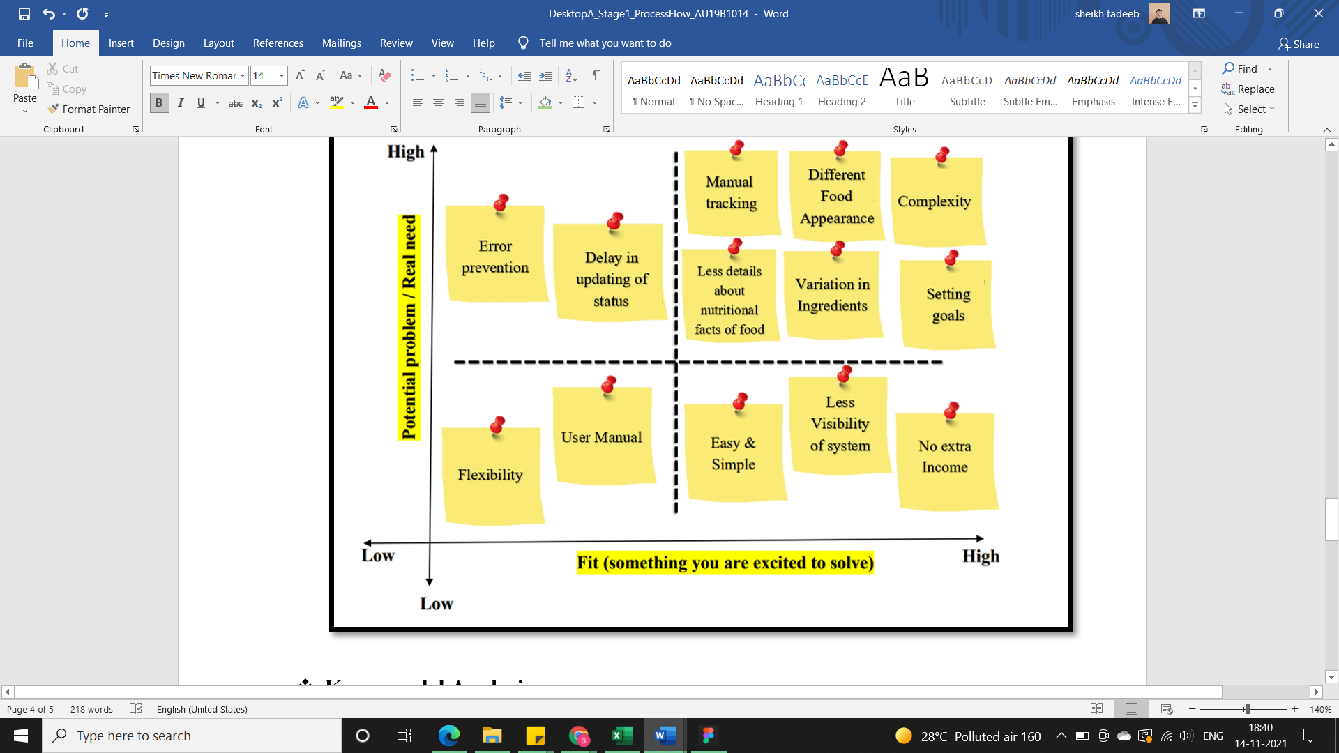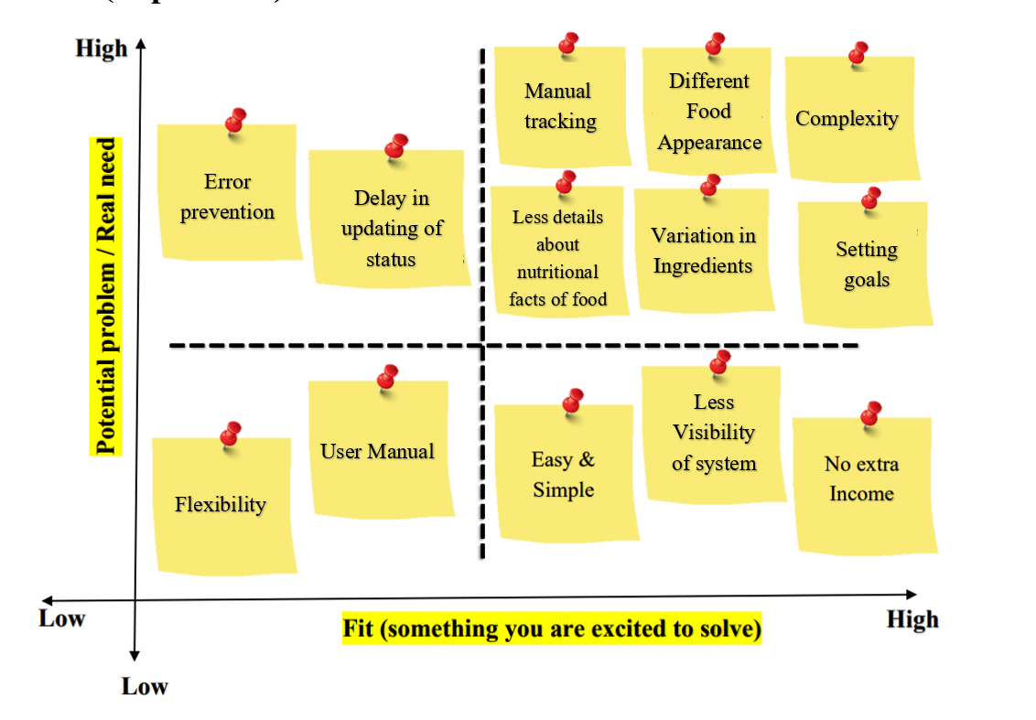

Poor Aesthetics

Manual Searching

Analyzing goods

Digital printing

Credit records

Hardcoded records

* **Kano-model Analysis:**

|  |  |  |
| --- | --- | --- |
| **Must be** | **Satisfactory** | **Delighters** |
| Digital records of goods purchased. | Aesthetical. | User Manual. |
| Digital records of goods sold. | Analyzing records. | Delay in updating status. |
| Printing of records. | Filtered Search. | - |
| Credit on business. | Error prevention. | - |
| Credit on Customers. | Flexibility | - |
| Checking goods availability. | - | - |

* 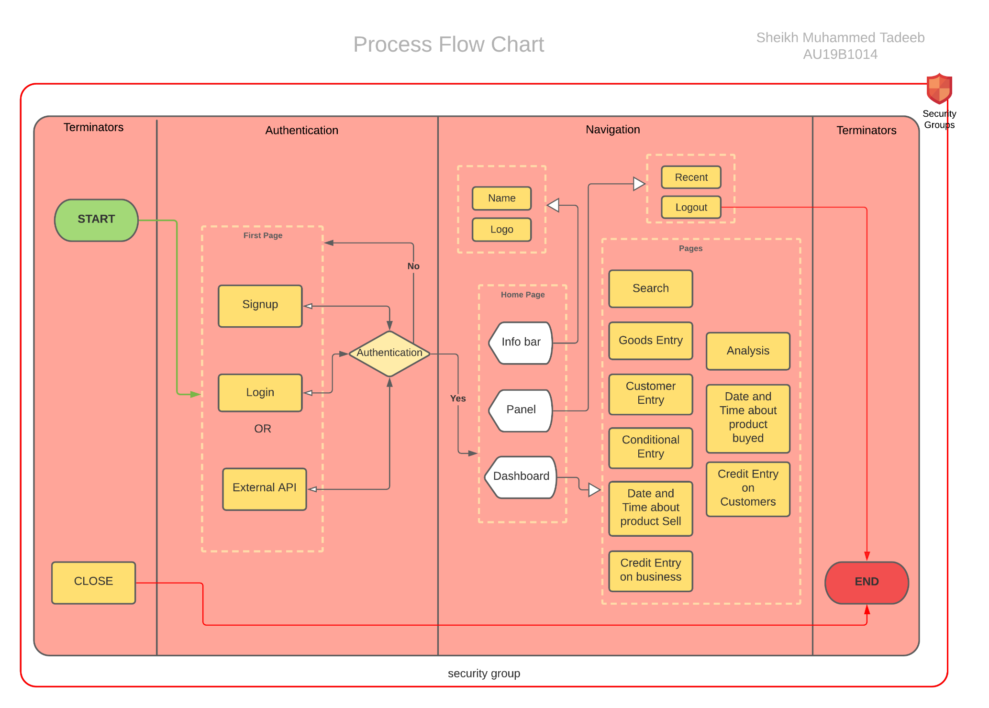**Flow diagram:**